Contents
01: A Note from the Author
02: Crystal Raven
03: Pandora’s Box
04: Malfunction
05: Promotions

A Note from the Author
With the world going insane, perhaps its time to escape to the sanity of fiction. Check out these books from my fellow writers and myself, and find your ticket to another world.

Crystal Raven
  - Book 1: Crystal Raven
Originally entitled Soul Catcher, I recently rebranded the series. Released on Inkwell, I recently received this review from a reader:
SOUL CATCHER was absolutely nothing like any other supernatural fiction I have ever read. The plot was very well constructed. The characters; they are some of the most unique and interesting cast ever introduced in any story. Mr.Lacoursiere seems to have extensive knowledge of hard to find literature on daemonology,Catholic theology, and the human condition. The way this book was written was done in such a way that it kept me up reading. At the same time, I wanted to read slowly, just to keep it going...I have read so much in my life. From fiction to non-fiction,history and biographies,to true crime and religious books. I don't usually take the time to do a book review,but this beautiful work deserves some words of acclaim for the artistic gift that it is. Anyone who would enjoy reading a fresh new perspective of supernatural,religious,daemonic,and everything else that is unusual...will LOVE this book.I am going to read the next story from this author now, and will be giving my opinion on the story after I finish. Thank you for this book. Amazing.

Crystal Raven. Available at:
https://www.amazon.com/dp/1708716734
And on Kindle at:
https://www.amazon.com/dp/B081KRCZTV
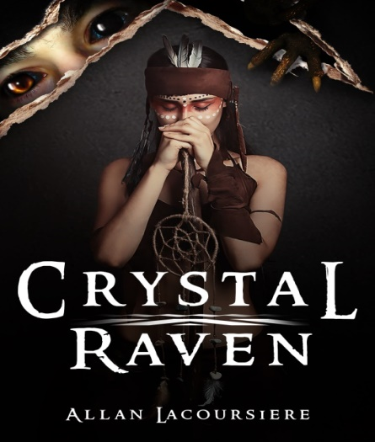

Available Now
  - Book 3 Pandora’s Box:
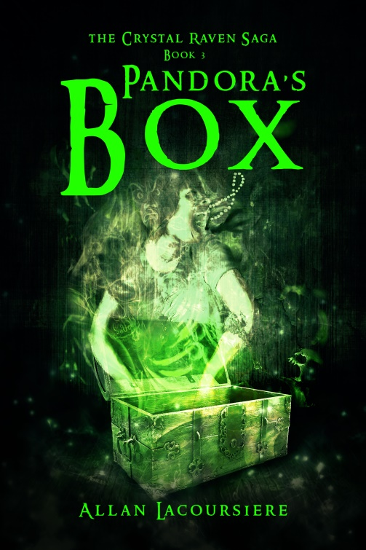
What harm could two little puppies cause? Fourteen-year-old Ember Darkeyes was about to find out when a stranger gives her two Hellhound puppies. While climbing a mountain in search of Pandora’s Box and the last artifact they need to end the war between the Brotherhood and the vampyres, she struggles with her growing menagerie of demons and a growing talent not seen in centuries. And all the while, she is haunted by the ghost of Jean-Claude. Surviving all this with her sanity still intact might not be possible, but if the vampyres catch up with the Ghost Sisterhood it might not matter.
Pandora’s Box Available at:
https://www.amazon.com/dp/B0858XM3Y8
And on Kindle at:
https://www.amazon.com/dp/B0858V1QNP

Malfunction
Despite the school year being cancelled, myself and the young writers from Pens of John Paul II continue to work on this year’s novel, Malfunction. It won’t come out until September, when schools reopen here in Ontario.
The story of a young student who tries to hide his disability, and the fall out when that secret comes out, this is a heartwarming coming of age tale from our John Paul II series.

Promotions

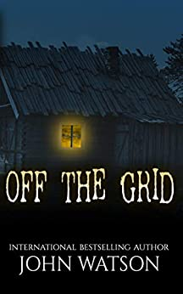

Ryan and Diana Richie have a happy life in New York City, but their goal has always been to downsize and live off the grid in a tiny home.
Their plans arrive sooner than expected after a brutal attack on the subway that leaves Diana desperate to leave big city life behind. Selling off all they own, the couple invests in a tiny house and set off on a cross country road trip to their new home in Oregon.
Along the way, they stay in countless trailer parks, and highway rest stops, acclimating to life in their humble new abode.
When they reach their last stop before home, they stop in at a remote community, where they plan to live for a week.
The question now is whether they will make it out alive.

https://storyoriginapp.com/swaps/7f96ff90-a0f4-11ea-8913-2be1ce77a717

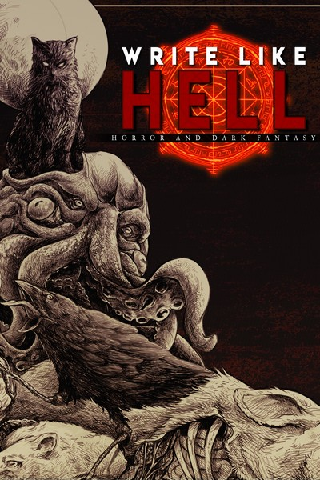

Write Like Hell is the first horror and dark fantasy anthology released by Sentinel Creatives. Adapted from the zine released under the same name, Write Like Hell features stories from Scott Miller, Justin Probyn and Mitchell Luthi.
Between these pages, you'll find a feast of fiction for you to sink your teeth into. This release see the debuts of not one but two writers.
Scott Miller's Panopticon is as unsettling as it is well-crafted. Pessimistic horror at its finest, this is a must read for fans of Connolly and Ligotti.
Justin Probyn's debut, Void Born, blends gritty sci-fi, gore and cosmic-horror into one seamless festival of the obscene.
Write Like Hell includes:
Dregmere - Mitchell Luthi
Panopticon –
Scott Miller
Void Born –
Justin Probyn

https://storyoriginapp.com/swaps/4bde5326-9ffd-11ea-a4a2-33b6d8b2c2b9

During this difficult time, I am wishing you and your family well. Stay safe. Stay home and read a book!

And as always, visit me at:

http://www.allanlacoursiere.com

