Contents
01: A Note from the Author
02: Crystal Raven
03: Pandora’s Box
04: Dark Haven
05: Promotions

A Note from the Aurthor
Unfortunately, during these days of pandemic, I have been deemed an essential worker. Due to the hours I work, and how draining this work can be, I have far less time for my writing. As a result, the release date of some books must be pushed back. For example, Alone – which is complete, all except its cover art – and Dark Haven will have to wait until after September, when my schedule is due to return to normal.
As a thank you to my readers for their patience, I will release Dark Haven for free on Good Reads, Story Origins, and other sites when it is ready.

Crystal Raven
  - Book 1: Crystal Raven
Originally entitled Soul Catcher, I recently rebranded the series. Released on Inkwell, I recently received this review from a reader:
SOUL CATCHER was absolutely nothing like any other supernatural fiction I have ever read. The plot was very well constructed. The characters; they are some of the most unique and interesting cast ever introduced in any story. Mr.Lacoursiere seems to have extensive knowledge of hard to find literature on daemonology,Catholic theology, and the human condition. The way this book was written was done in such a way that it kept me up reading. At the same time, I wanted to read slowly, just to keep it going...I have read so much in my life.From fiction to non-fiction,history and biographies,to true crime and religious books. I don't usually take the time to do a book review,but this beautiful work deserves some words of acclaim for the artistic gift that it is. Anyone who would enjoy reading a fresh new perspective of supernatural,religious,daemonic,and everything else that is unusual...will LOVE this book.I am going to read the next story from this author now, and will be giving my opinion on the story after I finish. Thank you for this book. Amazing.
- (*)(*) (*) (*) (*)
Overall Rating
- (*)(*) (*) (*) (*)
Plot
- (*)(*) (*) (*) (*)
Writing Style
- (*)(*) (*) (*) (*)
Grammar & Punctuation

Crystal Raven. Available at:
https://www.amazon.com/dp/1708716734
And on Kindle at:
https://www.amazon.com/dp/B081KRCZTV
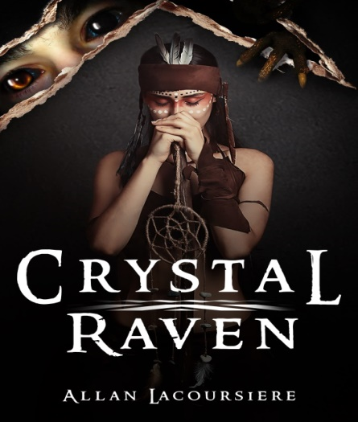

Available Now
  - Book 3 Pandora’s Box:
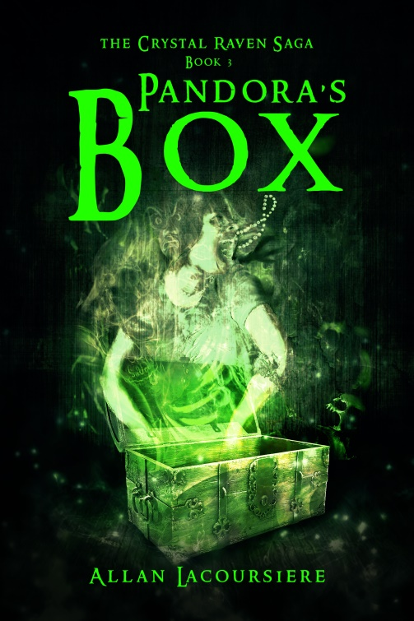
What harm could two little puppies cause? Fourteen-year-old Ember Darkeyes was about to find out when a stranger gives her two Hellhound puppies. While climbing a mountain in search of Pandora’s Box and the last artifact they need to end the war between the Brotherhood and the vampyres, she struggles with her growing menagerie of demons and a growing talent not seen in centuries. And all the while, she is haunted by the ghost of Jean-Claude. Surviving all this with her sanity still intact might not be possible, but if the vampyres catch up with the Ghost Sisterhood it might not matter.
Pandora’s Box Available at:
https://www.amazon.com/dp/B0858XM3Y8
And on Kindle at:
https://www.amazon.com/dp/B0858V1QNP

Dark Haven
For those who are interested in the evolution of a book, I am including the first chapter of Dark Haven. This is the rough draft, with all the blemishes. When it comes out after the final edit, you can compare the changes that have been made.

Chapter 1

She woke on a hard surface with something cold and damp nuzzling her neck. Ember opened one eye and immediately regretted it. Huckleberry’s nose found it at that exact second. She wanted to lay here and sleep, at least until the pounding in her head became a dull roar. But it was raining, and she was cold, wet and miserable, and not quite convinced she was still alive.
“Okay,” Ember grumped. “I’m up!”
It couldn’t be time for school. Summer vacation had only started two days ago, so why did she have to get up. Huckleberry’s tongue found a ticklish spot.
“I said I was up already.”
Ember struggled to lever herself to her knees, her head suddenly weighing more than her neck could support. She found herself on a road at the edge of a park, several other dark shapes lying nearby. She recognized Aiko’s foot, her thought she did. The only person she knew who wore those toed-boots – those Ninja boots – was the Japanese vampyre. So who was the third shape? Ember did her best to struggle to her feet and take up a fighting stance, suddenly convinced that her head felt this way because someone had thumped her. And if she was with Aiko, that someone had to be the third dark lump on the road.
“What are you doing, you silly little girl?” Jean-Claude asked, moving to her side to stare into her face.
“I’m getting ready to defend myself,” Ember snorted, and immediately regretted it. “You silly little ghost.”
“From Aiko and Alex?”
“That’s Alex?” Ember demanded.
“Of course it is,” the lump groaned. “Would you mind stop shouting. I feel like I drank half a lake of beer last night.”
“Oh,” Ember frowned, confused. “Were we at a party?”
“Who would invite you to such a party, you silly little girl,” Jean-Claude scolded. “You are too young for the booze and the wine.”
“I am not. I’m fifteen, and I will have you know, you silly little ghost, that plenty of fifteen-year-olds go to wild parties.”
“Ah,” Jean-Claude smiled triumphantly. “And how many of these fifteen-year-olds live with April Moonshadow?”
That shut Ember up. With April around, the closest thing she would come to a wild night out was a five-year-old’s birthday party. April ruled the brownstone and the girls who lived in it with an iron will and a quiet, but brittle voice. Even demons feared to cross her. Maybe when she was thirty or forty Ember would find the courage to sneak out to a party, until then, she satisfied her spite by sticking her tongue out at Jean-Claude.
Aiko came awake and rolled gracefully to her feet. “I thought you had given up talking to your imaginary friend.”
“He’s not imaginary, he’s just difficult to see.” Ember shrugged. “Ghosts can be like that.”
“I’m a ghost and you can see me,” Alex said.
“That’s only because you are wearing the ring,” Ember pointed out. “When you take it off, you disappear like any other ghost.”
“She has a point,” Aiko grinned.
The three stood in the rain, looking around at the shadows and the darkness. None of them had any memory of how they got here, nor could they see any familiar landmarks to help sort out their confusion.
“Ember? Aiko? Alex?” The figure of a young man stepped out from behind a nearby tree. “Is that you?”
The girls turned, instantly alert.
“Who are you?” Alex demanded.
“My name is Bowyer. I’ll explain later. Right now you must follow me before the Grim finds us out after curfew.”
The man turned back, beckoning to them urgently. “Hurry!”
“What are you silly little girls doing?” Jean-Claude scolded. “You heard the young boy, we must follow him quickly before the Grim finds us.”
“I’m not afraid of the Grim,” Ember said. “Not when I am with my girls. We can take anybody.”
“And what if the Grim is a thousand foot Eater of the Dead, mon petit?” Jean-Claude asked. “You know nothing of this place, eh, silly little girl. You don’t even know where you are.”
“What does Jean-Claude say?” Alex asked. There was no harm in asking. After all, she was a ghost, so it was possible Ember had her own personal haunt.
“He says we should follow the boy before the Grim finds us.”
Aiko shrugged and headed off into the park. The other two girls looked at each other and then followed their friend. The stranger led them diagonally through a park that was bathed in darkness. The trees were weeping willows that cast eerie shadows in the faint gaslight from the lamps scattered throughout the greenspace. Overhead, the clouds gathered in black banks, threatening to drown the world with their rain. There was nothing familiar about this place, nor anything that Ember saw to frighten her. Only the wet and the cold that she would rather do without, and if this stranger was leading her to shelter, that was good enough for the moment.
He led them across a second street to a darkened shop. An iron slab sat across the door. Bowyer reached beneath his robe and took out a chain of keys that hung around his neck. He inserted a cross with the familiar dagger point at the bottom, and Ember immediately mouthed Brotherhood to her companions. Neither responded. They watched as the iron slab slid across to reveal a second barrier of gopher wood. He again fished amongst the keys on his chain, drawing forth an Ankh, and Egyptian cross, which he inserted into another slot. When this barrier slid out of the way to reveal a normal door made of hawthorn wood, Ember grew annoyed. For all the hurry he seemed to be, all these doors seemed only to delay their escape from the cold rain.
Inside waited the all too familiar smell of books that Alex so loved. Even soaking wet, she would spend hours browsing these shelves. When Huckleberry set himself to shake off the water, she snapped, “don’t even think about it.”
Huckleberry gave her a mournful look.
“Hurry,” Bowyer urged. “We must get to the safe room at the back of the store. If a Grim patrol comes by, they will sense you are here.”
Reluctantly, Alex followed the others through the shelves of books to the back of the store. Here, Bowyer paused to open the door of an ancient safe, turning and pulling a lever until the door opened to reveal a spacious room beyond. He lit a lantern and beckoned the others inside, where they were confronted by a book the size of a kitchen table. It sat on a raised dais that dominated the centre of the room, it’s cover opened to a page somewhere near the middle of the book. Even from where they stood they could see the beautiful illumination that covered its pages, the hand painted letters decorated with vibrant colours. It immediately drew Jean-Claude, who hovered with his head inches from the page, a finger following the words.
“If you wait by the heater in the corner,” Bowyer suggested, “I will go get you some towels and some dry clothes.”
Aiko, unconcerned with nudity, had stripped out of half her wet clothes when Bowyer returned. The monk blushed and turned his back, awkwardly handing the towels and clothes to the vampyre before retreating across the room.
“Huckleberry, cover your eyes. There’s ladies dressing.” Ember called. The hound lay his head down and placed one of his paws across an eye. “And you, you silly little ghost, stop peaking.”
“I am too busy studying this book to worry about your naked bum, you silly little girl. Now hurry up and finish dressing so you can turn the pages for me.”
“What does Jean-Claude want?” Alex had already slipped into one of the robes provided by the monk and was hanging up their wet stuff to dry.
“He wants someone to turn the pages of that stuffy old book for him,” Ember rolled her eyes. “You know how Jean-Claude is. He’s got to read everything cover to cover, no matter how boring.”
Alex didn’t. She had never met the man, not in life or afterwards. But she did know what it felt like to love books, and she wanted to take a look at this one herself. “I’ll do it.”
Crossing over to the dais, she carefully flipped the pages back to the front of the book. As she did, she studied the strange writing and did not recognize the language. It definitely was not English.
“What language is this, Bowyer?”
“Ancient Sumerian,” Bowyer shrugged. “The same language every book is written in.”
“Don’t you have anything here written in English?” Alex wailed.
“One of the ancient languages,” Bowyer smiled and nodded his head. “I have the largest collection in the archipelago.”
The monk was gone for several minutes, and when he returned he was carrying a stack of twelve books. He set them on a table near Alex, beaming proudly. Turning from the larger book, she browsed through them. German, Japanese, and a couple that might have been Arabic. When she uncovered the only English book she could have cried. It was Dracula, and not even the Bram Stokes version, but a cheap knock off.
“Never mind that dribble, you silly little girl,” Jean-Claude scolded. “Hurry and turn the page. I must read this.”
“Jean-Claude wants you to save those wonderful works of art for later,” Ember called out, “and turn the page so he can read some more of that achingly dry dribble.”
“Sorry,” Alex blushed and reached up to turn the page, conveniently putting a hand through Jean-Claude’s head.
“No! No! This is not right, you silly little book!” Jean-Claude scolded. “None of it happened this way.”
“What?” Ember laughed. “If you don’t like the book, why are you so insistent on reading it, you silly little ghost?”
“It says we failed to stop Crystal that night in Upyr, you silly little girl, and that she fed on so many vampyres that she burst the seals of Hell. Further, the resulting cataclysm changed the surface of the world. Now turn, turn the page!”
“That’s ridiculous,” Ember scolded. “Crystal is back home. We killed her father, and then Aiko…”
“What?” Alex turned to face the other girl.
“We killed Crystal’s father…”
And both girls turned to watch the vampyre comb out her damp hair. Neither wanted to tell their friend that in the world they remembered, she and her lover, Alvero, had died with all the other vampyres that night.
“Yes,” Jean-Claude complained, “now turn the page so I can read the rest. I must study this, you silly little girls.”
“Okay,” Ember said, crossing to the book. “I will turn the page for you, but you need to tell me what is going on.”
“Mon petit, I cannot do that until I read more,” Jean soothed.
The book recorded the history since the cataclysm. Its claim that he did not arrive in time to prevent Crystal Raven from consuming almost half the vampyres in Upyr nearly broke his heart, and if he were not so fascinated with its text, he might have broken down and cried. As he read, Jean-Claude learned that millions died in the cataclysm that reshaped the Earth, leaving a world divided into three. Samuel know controlled the largest continent in what must be the remains of South America. The vampyre and their human allies managed to cling to an archipelago that was increasingly threatened by the other two parties, and everywhere else was ruled by Hsatan and his legions of Hell.
As Jean-Claude explained this to Ember, and she relayed it to the other girls, all three turned to look at their host. Finally, Aiko asked the question that was uppermost in all their minds.
“How did we get here?”
“That I cannot explain,” Bowyer looked down. “I only know that the Underground sent out messages to us all to look for you three, that you would be coming soon, and that you were our only hope of overthrowing the Prophesies of Hsatan and restoring the balance.”
“So you are Brotherhood?” Ember asked.
Bowyer grew pale and cast a glance over his shoulder. He held out his hands as if trying to push back the word to where it had come from, saying, “you mustn’t ever use that word. No one mentions them or the church that spawned them lest the Grim overhears you. It is a capital offense in Dark Haven and the territories it controls.”
“Then who are you?” Alex asked.
The Underground is a group of like-minded individuals who believe that Samuel and the demons must be stopped at any cost, even if it means Soul death. My family, the Fareyes, have been a part of the Underground since the first days of Armageddon, three hundred and thirty-two years ago. This is the first day in all that time that I truly believe it might be possible.”
A clock chimed, starting the slow count to twelve. “Hurry, we must move into the crèche. It is almost the dark hour.”
Forgetting himself, Bowyer grabbed Ember’s arm and pushed her towards the back of the room. Huckleberry leapt to his feet, baring his teeth in a growl that started deep in his throat. Still panicked, the monk gathered the others up and hustled them to a door at the back of the room, pulling the dog along with him as Huckleberry latched onto the back of his robe and refused to let go. Suddenly, all three girls, the hound, Jean-Claude and the monk were jammed into a room barely bigger than a closet. They stood, cheek to cheek, wondering what had caused this terror as the clock struck twelve.
“For a moment,” Bowyer breathed, “I didn’t think we would make it in time.”
“In time for what?” Aiko grated, trying to dig Ember’s elbow out of her side, and Huckleberry’s nose out of her butt.
“The dark hour,” Bowyer explained, “when the demons are at their full power. While they cannot attack us directly because of the Covenant, the pestilence and the creatures they release on the Earth can be dangerous. Every night we must retreat to these warded safe rooms until the morning.”
“You expect us to stand like this all night,” Ember complained. “Alex has her fat butt in my eye.”
“That’s not my butt,” Alex laughed, “and if you don’t stop spitting on my shirt I’m going to personally feed you to the first demon we meet.”
Bowyer bowed his head. “I am sorry about the accommodations. I live alone, and have never had a need for a larger crèche. Besides, curios and books from the before time do not sell as well as one would think.”

Promotions

My book and others are featured in a virtual book fair. Take a look!

https://clcannon.net/bookfair

During this difficult time, I am wishing you and your family well. Stay safe. Stay home and read a book!

And as always, visit me at:

http://www.allanlacoursiere.com

