Contents
01: Cantara
02: Wiccan Apotropaic
03: Pandora’s Box
04: The Crystal Raven Sagas
05: Promotions

Cantara
A Djinn trapped by her thirst for vengeance on this plane, she was convinced to join the Brotherhood by her lover, the Wandering Jew. As a member of this secret order, she is able to continue her personal war against the Vampyres.
A cold, and merciless killer of demons and vampyres, she was the last being anyone would entrust the protection of a group of teenagers; and yet, these same traits make her the perfect candidate. When asked to do a small favour for a certain French Canadian monk, she should have known better. Jean-Claude’s small favours have a way of becoming minor disasters.
Join Cantara and the rest of the specialists in the Crystal Raven series.

Crystal Raven. Available at:
https://www.amazon.com/dp/1708716734
And on Kindle at:
https://www.amazon.com/dp/B081KRCZTV
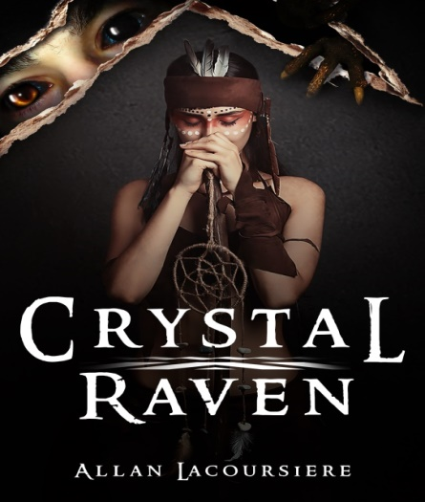

Wiccan Apotropaic
  - Book 2 Wiccan Apotropaic
When you send a group of teenage girls off to an innocent volleyball tournament what could possibly to wrong? When these girls are demon-hunters like the Ghost Sisterhood, more than you can imagine. A haunted house, a poltergeist, a stranger, and a vengeful demon…. Who would survive to return to New York City?
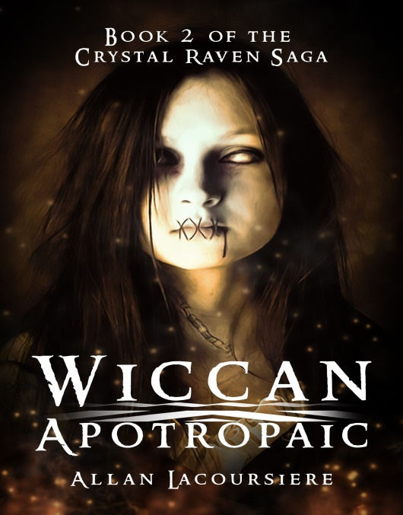

Wiccan Apotropaic. Available at:
https://www.amazon.com/dp/1658762045
And on Kindle at:
https://www.amazon.com/dp/B083QTSK3G

Available Now
  - Book 3 Pandora’s Box:
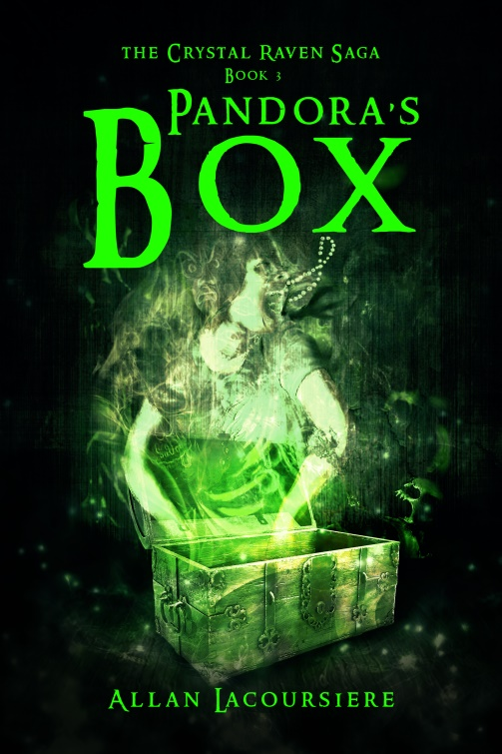
What harm could two little puppies cause? Fourteen-year-old Ember Darkeyes was about to find out when a stranger gives her two Hellhound puppies. While climbing a mountain in search of Pandora’s Box and the last artifact they need to end the war between the Brotherhood and the vampyres, she struggles with her growing menagerie of demons and a growing talent not seen in centuries. And all the while, she is haunted by the ghost of Jean-Claude. Surviving all this with her sanity still intact might not be possible, but if the vampyres catch up with the Ghost Sisterhood it might not matter.
Pandora’s Box Available at:
https://www.amazon.com/dp/B0858XM3Y8
And on Kindle at:
https://www.amazon.com/dp/B0858V1QNP

The Crystal Raven Sagas
Crystal Raven Saga:
Crystal Raven
Wiccan Apotropaic
Pandora’s Box
Chapel Perilous
Hells Gate: Back story of Alexandra

Coming Soon:
Strengoni Benefici: Trilogy covering the backstory of Alvaro

Dark Haven: Ten book saga featuring Ember, Alex, Aiko and Jean-Claude.
Dark Haven
Flying Dutchman
Jungle Queen
Wiccan Island
Frozen Cliffs
Night Blossoms
Atlantis
Arabian Knights
Wanderers
Final Chapter

Monk: Trilogy covering Jean-Claude’s backstory
Black Rose: The backstory of Black Rose and Jean-Claude.
Black Lotus: Trilogy covering the backstory of Aiko
Nightstalker: Trilogy that continues the story of Ember and Delph.

Promotions

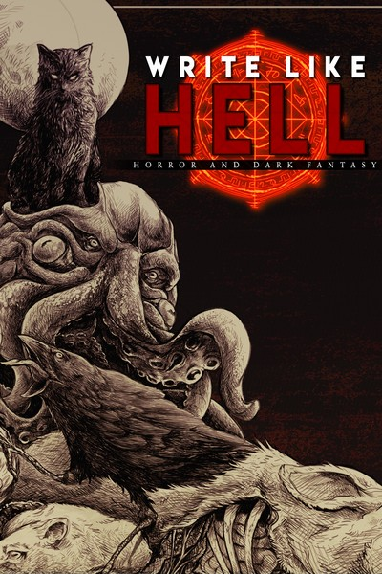

https://storyoriginapp.com/swaps/69ab06fe-5482-11ea-ba48-d79715d74e1c

Write Like Hell is the first horror and dark fantasy anthology released by Sentinel Creatives. Adapted from the zine released under the same name, Write Like Hell features stories from Scott Miller, Justin Probyn and Mitchell Luthi. Between these pages, you'll find a feast of fiction for you to sink your teeth into. This release see the debuts of not one but two writers. Scott Miller's Panopticon is as unsettling as it is well-crafted. Pessimistic horror at its finest, this is a must read for fans of Connolly and Ligotti. Justin Probyn's debut, Void Born, blends gritty sci-fi, gore and cosmic-horror into one seamless festival of the obscene. Write Like Hell includes: Dregmere - Mitchell Luthi Panopticon - Scott Miller Void Born - Justin Probyn

https://storyoriginapp.com/swaps/411ee40a-4e81-11ea-b2b3-5338377e743d

A.F. Stewart
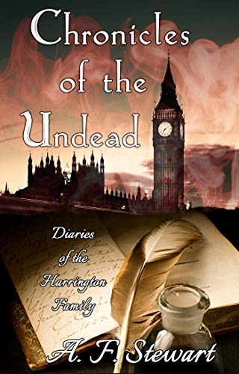

Three generations bound together under a horrifying family secret.
Vampires exist.
Inside the personal journals of the Harrington family, watch a dark and dangerous odyssey unfold. Three members of this tormented family, Samuel, his son Edmund, and Edmund's daughter Charlotte, must come to terms with evil. Set during the 18th and 19th century in London, England, this family must struggle against horror as their lives intersect with supernatural forces. As two intriguing vampires befriend, manipulate, and play with all three souls, altering their lives forever.
Their fears, private confidences and weaknesses are revealed as one selfish act ends in horrific tragedy, with far-reaching consequences.
Who succumbs to the seduction and danger of the vampire? Who grapples to combat the evil influence that permeates their lives? Find out in Chronicles of the Undead.

During this difficult time, I am wishing you and your family well. Stay safe. Stay home and read a book!

And as always, visit me at:

http://www.allanlacoursiere.com

