Contents
01: Alvaro de San Carlos
02: Wiccan Apotropaic
03: Pandora’s Box
04: The Crystal Raven Sagas
05: Promotions

Alvaro de San Carlos
Alvaro de San Carlos is a Stregoni Benefici, one of the oldest known European vampyres, and the first of the specialists to join the Brotherhood. Born during the rise of Rome, he and his six brothers spent much of their early days in the legions, until one day they stumbled on a young Christian woman. Alvaro slew all six of his brothers to save the woman he loved.
He spent much of his career with the Brotherhood working with the Wandering Jew, Angel and Cantara. When a diminutive Frenchman asked for a small favour, Alvaro should have remembered that Jean-Claude’s favours always ended up as minor disasters.
Join Alvaro and the rest of the specialists in the Crystal Raven series.

Crystal Raven. Available at:
https://www.amazon.com/dp/1708716734
And on Kindle at:
https://www.amazon.com/dp/B081KRCZTV
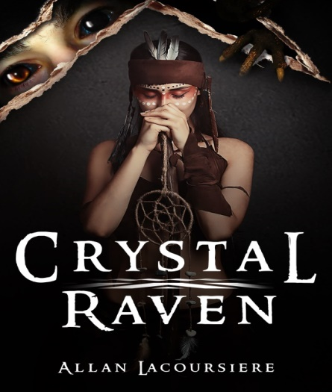

Wiccan Apotropaic
  - Book 2 Wiccan Apotropaic
When you send a group of teenage girls off to an innocent volleyball tournament what could possibly to wrong? When these girls are demon-hunters like the Ghost Sisterhood, more than you can imagine. A haunted house, a poltergeist, a stranger, and a vengeful demon…. Who would survive to return to New York City?
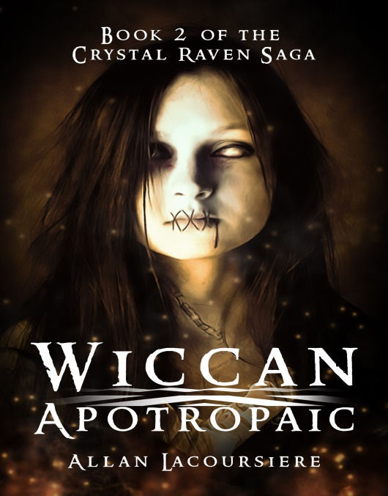

Wiccan Apotropaic. Available at:
https://www.amazon.com/dp/1658762045
And on Kindle at:
https://www.amazon.com/dp/B083QTSK3G

Upcoming Books
  - Book 3 Pandora’s Box:
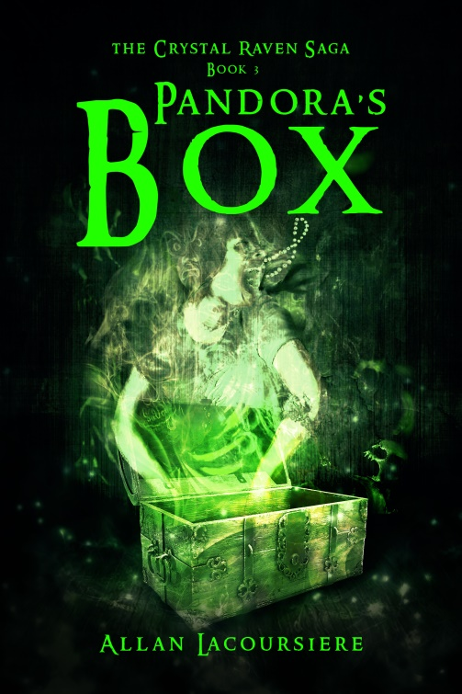
What harm could two little puppies cause? Fourteen-year-old Ember Darkeyes was about to find out when a stranger gives her two Hellhound puppies. While climbing a mountain in search of Pandora’s Box and the last artifact they need to end the war between the Brotherhood and the vampyres, she struggles with her growing menagerie of demons and a growing talent not seen in centuries. And all the while, she is haunted by the ghost of Jean-Claude. Surviving all this with her sanity still intact might not be possible, but if the vampyres catch up with the Ghost Sisterhood it might not matter.

The Crystal Raven Sagas
Crystal Raven Saga:
Crystal Raven
Wiccan Apotropaic
Pandora’s Box
Chapel Perilous
Hells Gate: Back story of Alexandra

Coming Soon:
Strengoni Benefici: Trilogy covering the backstory of Alvaro
Dark Haven: Ten book saga featuring Ember, Alex, Aiko and Jean-Claude.
Monk: Trilogy covering Jean-Claude’s backstory
Black Rose: The backstory of Black Rose and Jean-Claude.
Black Lotus: Trilogy covering the backstory of Aiko
Nightstalker: Trilogy that continues the story of Ember and Delph.

Promotions

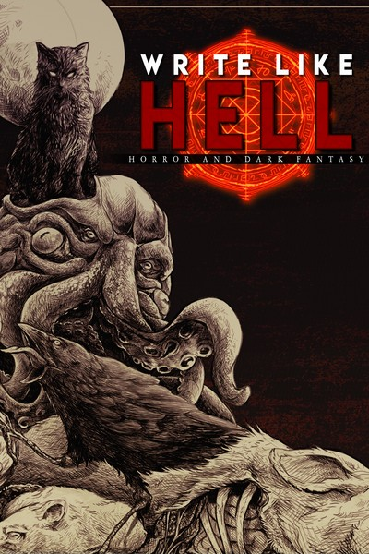

https://storyoriginapp.com/swaps/69ab06fe-5482-11ea-ba48-d79715d74e1c

Write Like Hell is the first horror and dark fantasy anthology released by Sentinel Creatives. Adapted from the zine released under the same name, Write Like Hell features stories from Scott Miller, Justin Probyn and Mitchell Luthi. Between these pages, you'll find a feast of fiction for you to sink your teeth into. This release see the debuts of not one but two writers. Scott Miller's Panopticon is as unsettling as it is well-crafted. Pessimistic horror at its finest, this is a must read for fans of Connolly and Ligotti. Justin Probyn's debut, Void Born, blends gritty sci-fi, gore and cosmic-horror into one seamless festival of the obscene. Write Like Hell includes: Dregmere - Mitchell Luthi Panopticon - Scott Miller Void Born - Justin Probyn

And as always, visit me at:

http://www.allanlacoursiere.com

