Contents
01: Ember Darkeyes
02: Wiccan Apotropaic
03: Pandora’s Box
04: Dark Queen
05: Promotions

Ember Darkeyes

Ember Darkeyes is a traditional wizard, and like all traditional wizards, she communes with demons. What this means if you are trying to raise a fourteen-year-old wizard is that you have to put up with her pets. Like the two Hell Hound puppies, Strawberry and Tangerine, and her little blue imp who likes to sit in the supper pot while it is cooking.
Join Ember, Crystal and the rest of the Ghost Sisterhood as they discover their latent talents in the Crystal Raven series.

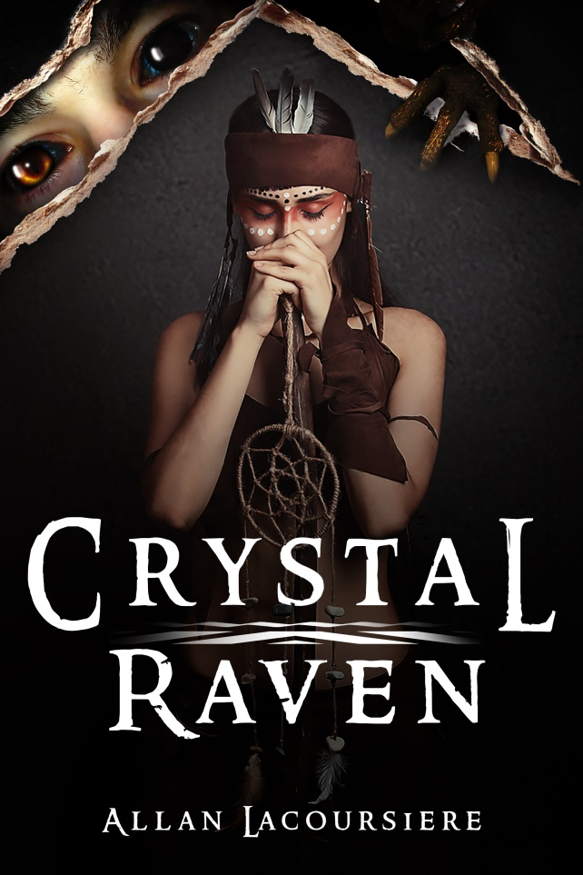
Crystal Raven. Available at:
https://www.amazon.com/dp/1708716734
And on Kindle at:
https://www.amazon.com/dp/B081KRCZTV

Wiccan Apotropaic
Book 2 Wiccan Apotropaic
When you send a group of teenage girls off to an innocent volleyball tournament what could possibly to wrong? When these girls are demon-hunters like the Ghost Sisterhood, more than you can imagine. A haunted house, a poltergeist, a stranger, and a vengeful demon…. Who would survive to return to New York City?
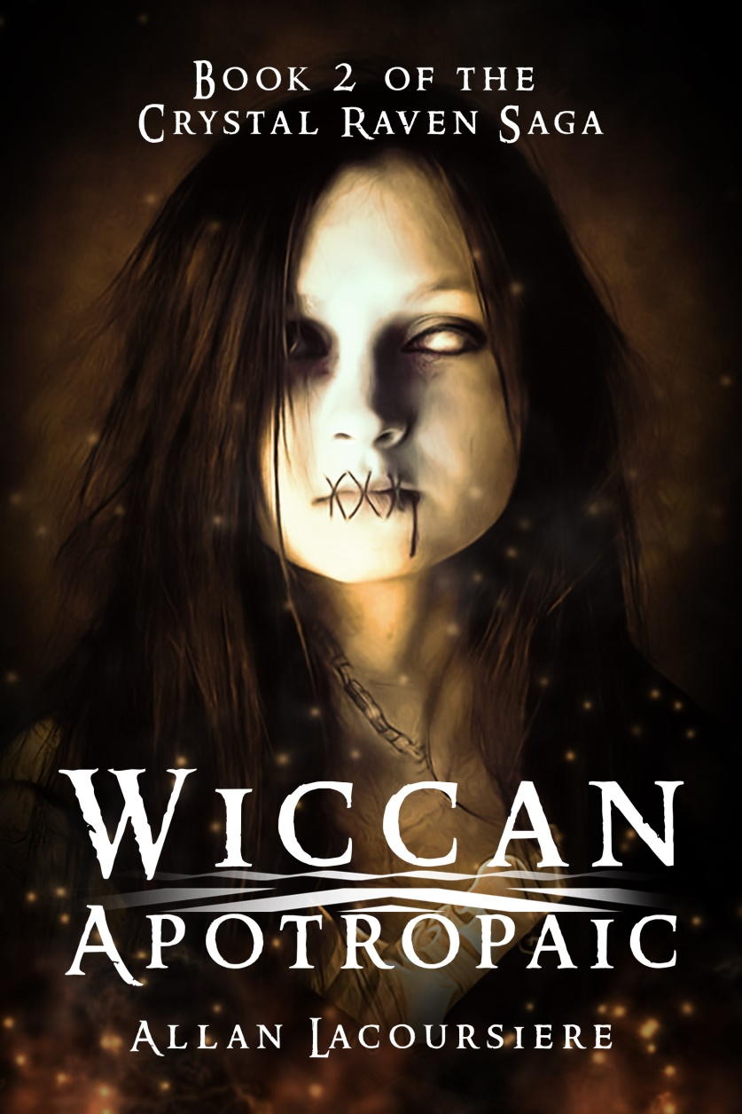
Wiccan Apotropaic. Available at:
https://www.amazon.com/dp/1658762045
And on Kindle at:
https://www.amazon.com/dp/B083QTSK3G

Upcoming Books
Book 3 Pandora’s Box:
What harm could two little puppies cause? Fourteen-year-old Ember Darkeyes was about to find out when a stranger gives her two Hellhound puppies. While climbing a mountain in search of Pandora’s Box and the last artifact they need to end the war between the Brotherhood and the vampyres, she struggles with her growing menagerie of demons and a growing talent not seen in centuries. And all the while, she is haunted by the ghost of Jean-Claude. Surviving all this with her sanity still intact might not be possible, but if the vampyres catch up with the Ghost Sisterhood it might not matter.

Promotions

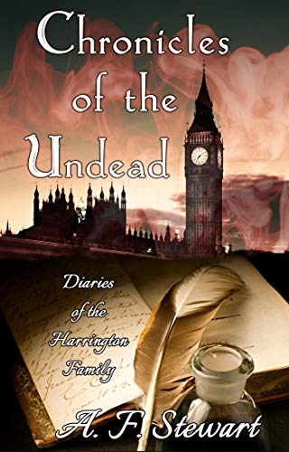

https://www.amazon.ca/dp/B07D1D5J7R

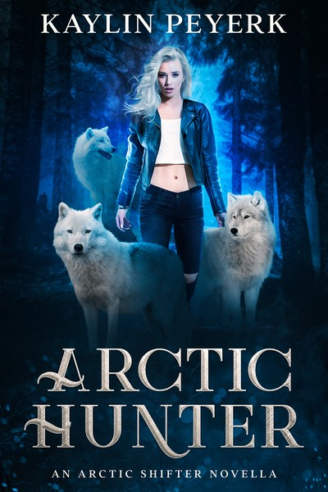

https://www.amazon.ca/dp/B081PDFQHM

And as always, visit me at:

http://www.allanlacoursiere.com

