Contents
01: Free Ebook
02: Les Trente-Six Mois: The Life and of Nicolas Rivard Sieur de Lavigne
03: Alone/ The Medicine Man
04: The Canadians
05: Promotions

Free Ebook
.

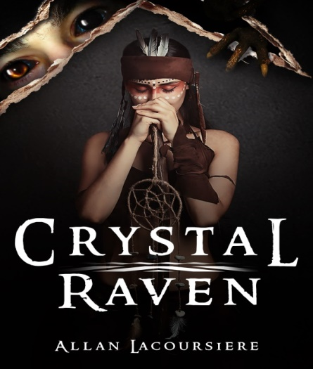

A long-ago Pope and his Succubus lover uncover a conspiracy to overturn the established order in Heaven and on Earth. Together they created a Brotherhood of demon hunters and embedded them deep inside the church.
Seven Hundred years later, a monk finds a badly beaten young girl, unaware that he has set in motion a chain of events that will lead to Armageddon. Can he discover her true nature in time to prevent the extinction of all life? Find out. Follow the link for your free copy of Crystal Raven.
https://storyoriginapp.com/giveaways/48c1c62e-93fe-11ea-8766-fb95780f64e6

Les Trente-Six Mois
https://www.amazon.com/dp/1537535544
https://www.amazon.com/dp/B07HBQ4BX8

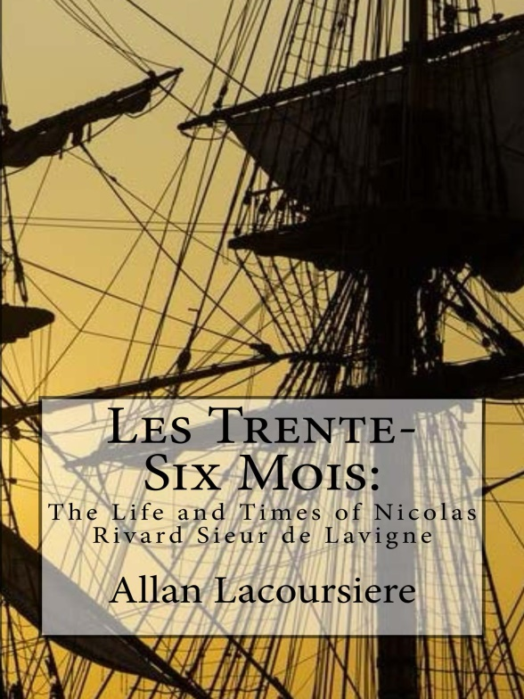
A thirty-six-month contract in the New World meant surviving harsh winters, hostile natives, strange diseases, scurvy and hunger. Few men and women stayed beyond the end of their contract. Nicolas Rivard Sieur de Lavigne was one of these men. His children would help build two nations across the face of North America. Their descendants would take names like Rivard, Lavigne, Lacoursiere, Laglanderie, Dufresne, Lanouette, Préville, Beaucourt, Preville, Loraner, Feuilleverte, Bellefeuille, Monendre, Maisonville, Mongrain, Rivac, Rival, Rivvault, Vertefeuille, and Lamy. This is his story.

Alone/The Medicine Man
https://www.amazon.com/dp/B08CBHBYFM

https://www.amazon.com/dp/B08C98YX52

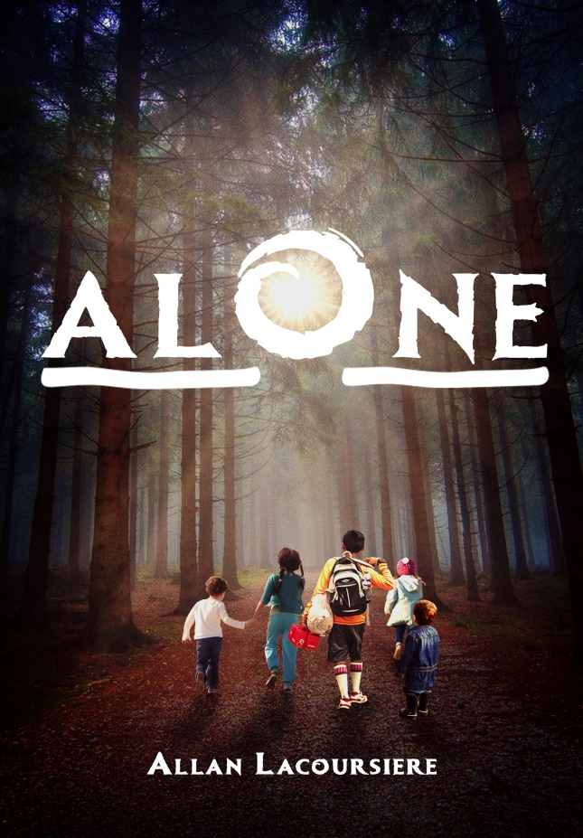

Set in the 1950’s, when plagues ravaged our Northern Canadian native communities, five Inuit children are taken from their homes and sent to a residential school.
Shortly after arriving, Alornerk, the eldest of the five, runs away with the other children and attempts to cross all of Northern Canada to return home. Join him in a tale of adventure, of laughter, and of tragedy, because sometimes you can never go home.

If you like Alone, You might also like The Medicine Man

https://www.amazon.com/dp/B07DYXTYD3
https://www.amazon.com/dp/1721737308

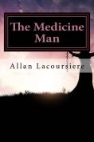

Chapel Perilous
Coming in two weeks

As the war wages on, and demons rise from Hell in bubbles of evil, follow Crystal and the Ghost Sisterhood deep beneath a cenote for the final confrontation with her father.

Promotions

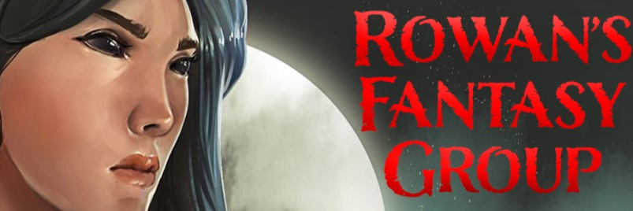

Fantasy for adult and young adult promote and review
Get these books fast! This promotion ends August 4th!

Get these books fast! This promotion ends July 30th!
https://storyoriginapp.com/to/Byr7Zro

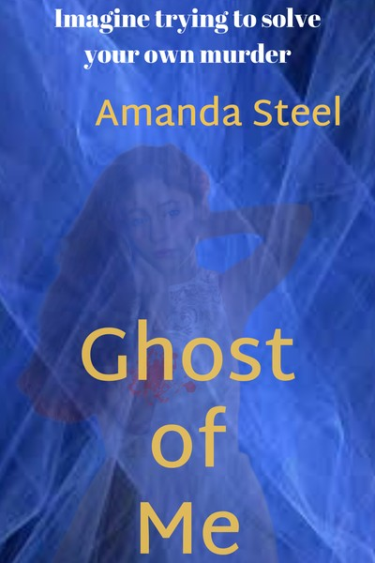

Imagine getting the chance to solve your own murder. For Sarah, the prospect becomes a reality after finding her dead body in the morgue and deciding that the injuries sustained indicate she was murdered. She won’t let being a ghost stop her from tracking down the murderer and stopping him from killing again. However, she’ll need help from someone living. She finds that help in the form of Steve; a near recluse who sees ghosts and isn’t thrilled at the idea of Sarah appearing in his house whenever she feels like it. Can they work together and save lives, or will more women have to die?

Serena is a world class necromancer, a self-proclaimed master of the undead. But when someone starts killing the remaining witches, she must fight for her life against an enemy that is immune to the dark arts. With only her undead companion by her side, she must discover the unstoppable evil that is killing her kind and find a way to avoid the fate shared by her spellcasting companions. There is a new player in town. Stronger than anything she’s ever seen, and even with her command of the undead, she may not last the night. Experience this fun and thrilling ride in the life of Serena as she communes with dark forces, screws over evil, and raises Hell. Read it now, before the darkness comes. Seriously, it may already be too late...

https://storyoriginapp.com/swaps/b3b15192-b812-11ea-b800-57798d3a95a6

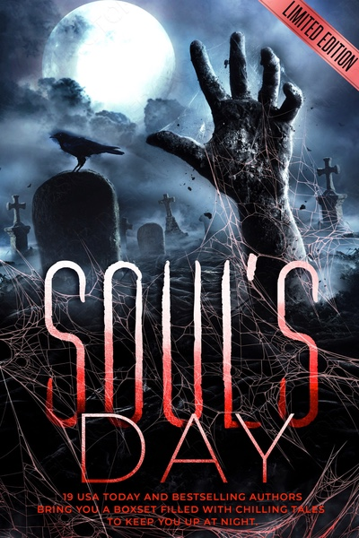

Old Hallows Eve, when things go bump in the night,
Children come to play, and the witches provide the fright.
For 19 authors, USA Today and international bestselling,
The Halloween tales become more than this foretelling.
In the Soul's Day Boxset, a mansion feeds on souls,
A gargoyle captures them, and a demon dungeon master makes the calls,
Campers gets picked off one by one,
The Karnaval's corn dogs are less than fun,
Ghosts lurking around every bend,
'I do' at the wedding is the very end.
A boxset of chills and thrills to keep you up at night,
One-click pre-order to snap your copy filled with fright.
On old Hallow's eve when creatures come to play,
With this spine chilling pages, it's where you'll want to stay.
AUTHOR LINE UP:
Erin Lee - USA TODAY BESTSELLING
Kristin Ping w/a Judith Holstrom - USA TODAY BESTSELLING
Amber Garr - AWARD AND INTERNATIONAL BESTSELLING
Ashlee Sinn - AWARD AND INTERNATIONAL BESTSELLING
L.L. Hunter - AWARD AND INTERNATIONAL BESTSELLING
Monique Singleton - INTERNATIONAL BESTSELLING
Majanka Verstraete - INTERNATIONAL BESTSELLING
Aubrey Wynne - INTERNATIONAL BESTSELLING
Stephanie Ayers - INTERNATIONAL BESTSELLING
DM Wolfenden - INTERNATIONAL BESTSELLING
Maggie Tideswell - INTERNATIONAL BESTSELLING
Sian B. Claven - AWARD WINNING AUTHOR
Kayla Krantz
Yvette Bostic
Brandy Nacole
Jennifer Fish-Ferguson
Lea Cherry
Scarlet Le Clair
Azaaa Davis
https://storyoriginapp.com/swaps/c0426c22-b6f8-11ea-be4e-df10aedf68bf

During this difficult time, I wish you and your family well. Stay safe. Stay home and read a book!

And as always, visit me at:

http://www.allanlacoursiere.com

