Contents
01: Free Ebook
02: Les Trente-Six Mois: The Life and of Nicolas Rivard Sieur de Lavigne
03: Pens of John Paul II Malfunction
04: Alone
05: Promotions

Free Ebook
.

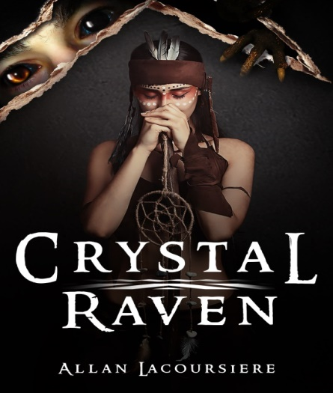

A long-ago Pope and his Succubus lover uncover a conspiracy to overturn the established order in Heaven and on Earth. Together they created a Brotherhood of demon hunters and embedded them deep inside the church.
Seven Hundred years later, a monk finds a badly beaten young girl, unaware that he has set in motion a chain of events that will lead to Armageddon. Can he discover her true nature in time to prevent the extinction of all life? Find out. Follow the link for your free copy of Crystal Raven.
https://storyoriginapp.com/giveaways/48c1c62e-93fe-11ea-8766-fb95780f64e6

Les Trente-Six Mois
https://www.amazon.com/dp/1537535544
https://www.amazon.com/dp/B07HBQ4BX8

A thirty-six-month contract in the New World meant surviving harsh winters, hostile natives, strange diseases, scurvy and hunger. Few men and women stayed beyond the end of their contract. Nicolas Rivard Sieur de Lavigne was one of these men. His children would help build two nations across the face of North America. Their descendants would take names like Rivard, Lavigne, Lacoursiere, Laglanderie, Dufresne, Lanouette, Préville, Beaucourt, Preville, Loraner, Feuilleverte, Bellefeuille, Monendre, Maisonville, Mongrain, Rivac, Rival, Rivvault, Vertefeuille, and Lamy. This is his story.

Pens of John Paul II
Our third book: Malfunction

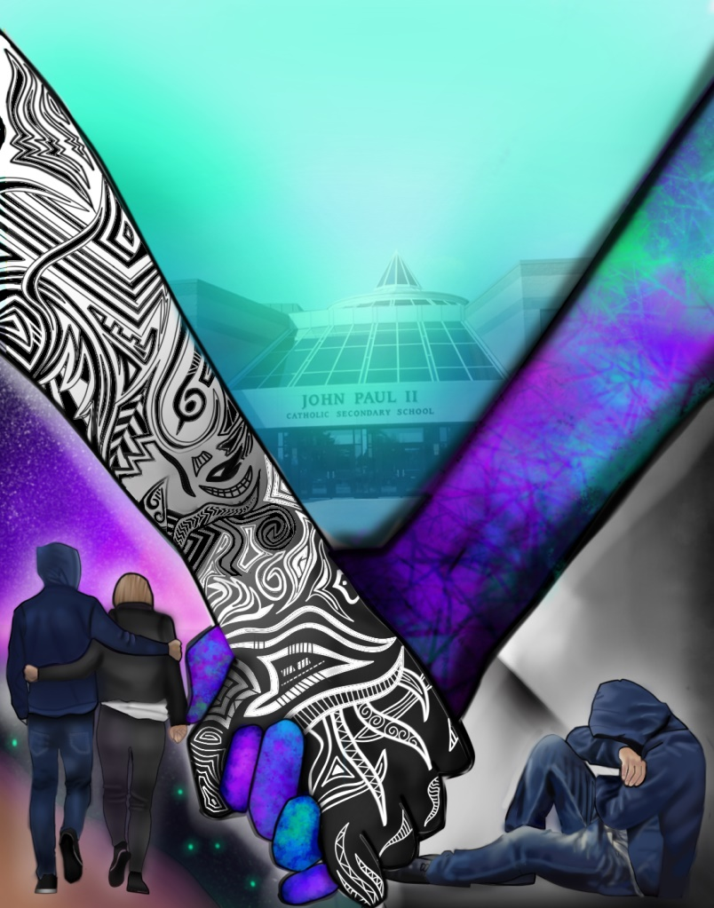

Each year we have a competition amongst the student body to create our cover art. This year, Shannon Fawcett created this drawing for the cover of our novel Malfunction.
Now that I am no longer an essential worker, the kids and I are working hard to complete our third novel from our John Paul II series. We anticipate having it complete by August. If any of you are interested in supporting the library at John Paul II Catholic Secondary School, I will include a link for this novel in a future newsletter.

Alone
Coming the end of July.

Set in the 1950’s, when plagues ravaged our Northern Canadian native communities, five Inuit children are taken from their homes and sent to a residential school.
Shortly after arriving, Alornerk, the eldest of the five, runs away with the other children and attempts to cross all of Northern Canada to return home. Join him in a tale of adventure, of laughter, and of tragedy, because sometimes you can never go home.

Promotions

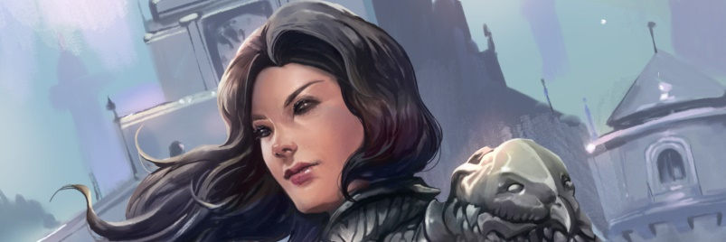

Foreboding A Black Eyed Witch Novel

Get these books fast! This promotion ends July 30th!

https://storyoriginapp.com/to/DZMSlOb

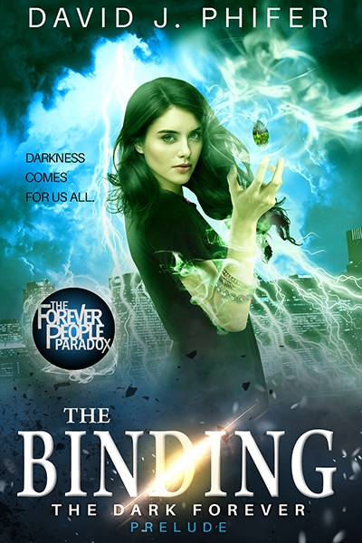

What if Deadpool was a Sassy Witch?
Fun thrills with a necromancer and her undead companion
Get the story!
Available in PDF, MOBI, and ePub
Serena is a world class necromancer, a self-proclaimed master of the undead. But when someone starts killing the remaining witches, she must fight for her life against an enemy that is immune to the dark arts. With only her undead companion by her side, she must discover the unstoppable evil that is killing her kind and find a way to avoid the fate shared by her spellcasting companions. There is a new player in town. Stronger than anything she’s ever seen, and even with her command of the undead, she may not last the night. Experience this fun and thrilling ride in the life of Serena as she communes with dark forces, screws over evil, and raises Hell. Read it now, before the darkness comes. Seriously, it may already be too late...

https://storyoriginapp.com/swaps/b3b15192-b812-11ea-b800-57798d3a95a6

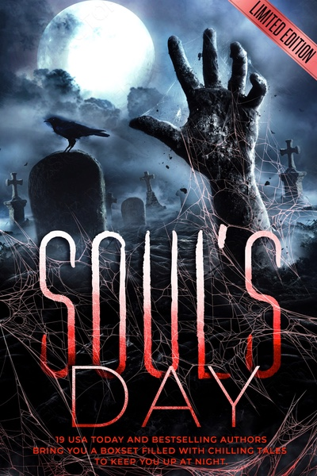

Old Hallows Eve, when things go bump in the night,
Children come to play, and the witches provide the fright.
For 19 authors, USA Today and international bestselling,
The Halloween tales become more than this foretelling.
In the Soul's Day Boxset, a mansion feeds on souls,
A gargoyle captures them, and a demon dungeon master makes the calls,
Campers gets picked off one by one,
The Karnaval's corn dogs are less than fun,
Ghosts lurking around every bend,
'I do' at the wedding is the very end.
A boxset of chills and thrills to keep you up at night,
One-click pre-order to snap your copy filled with fright.
On old Hallow's eve when creatures come to play,
With this spine chilling pages, it's where you'll want to stay.
AUTHOR LINE UP:
Erin Lee - USA TODAY BESTSELLING
Kristin Ping w/a Judith Holstrom - USA TODAY BESTSELLING
Amber Garr - AWARD AND INTERNATIONAL BESTSELLING
Ashlee Sinn - AWARD AND INTERNATIONAL BESTSELLING
L.L. Hunter - AWARD AND INTERNATIONAL BESTSELLING
Monique Singleton - INTERNATIONAL BESTSELLING
Majanka Verstraete - INTERNATIONAL BESTSELLING
Aubrey Wynne - INTERNATIONAL BESTSELLING
Stephanie Ayers - INTERNATIONAL BESTSELLING
DM Wolfenden - INTERNATIONAL BESTSELLING
Maggie Tideswell - INTERNATIONAL BESTSELLING
Sian B. Claven - AWARD WINNING AUTHOR
Kayla Krantz
Yvette Bostic
Brandy Nacole
Jennifer Fish-Ferguson
Lea Cherry
Scarlet Le Clair
Azaaa Davis
https://storyoriginapp.com/swaps/c0426c22-b6f8-11ea-be4e-df10aedf68bf

During this difficult time, I wish you and your family well. Stay safe. Stay home and read a book!

And as always, visit me at:

http://www.allanlacoursiere.com

