Contents
01: Free Ebook
02: Les Trente-Six Mois: The Life and of Nicolas Rivard Sieur de Lavigne
03: Wiccan Apotropaic
04: Ware the Milk Rabbit and Crossroads
05: Promotions

Free Ebook
.

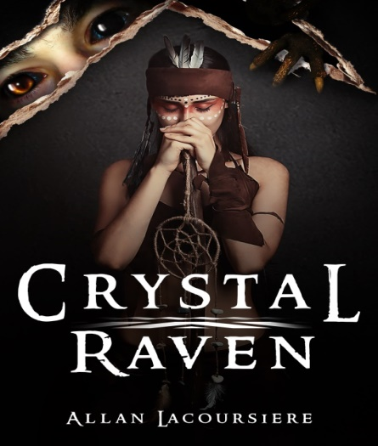

A long-ago Pope and his Succubus lover uncover a conspiracy to overturn the established order in Heaven and on Earth. Together they created a Brotherhood of demon hunters and embedded them deep inside the church.
Seven Hundred years later, a monk finds a badly beaten young girl, unaware that he has set in motion a chain of events that will lead to Armageddon. Can he discover her true nature in time to prevent the extinction of all life? Find out. Follow the link for your free copy of Crystal Raven.
https://storyoriginapp.com/giveaways/48c1c62e-93fe-11ea-8766-fb95780f64e6

Les Trente-Six Mois
https://www.amazon.com/dp/1537535544
https://www.amazon.com/dp/B07HBQ4BX8

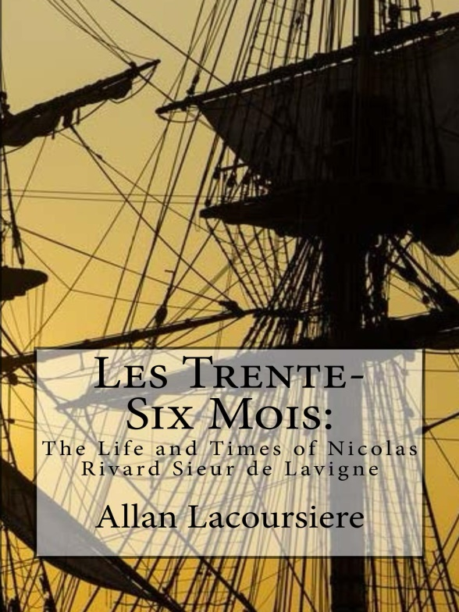
A thirty-six-month contract in the New World meant surviving harsh winters, hostile natives, strange diseases, scurvy and hunger. Few men and women stayed beyond the end of their contract. Nicolas Rivard Sieur de Lavigne was one of these men. His children would help build two nations across the face of North America. Their descendants would take names like Rivard, Lavigne, Lacoursiere, Laglanderie, Dufresne, Lanouette, Préville, Beaucourt, Preville, Loraner, Feuilleverte, Bellefeuille, Monendre, Maisonville, Mongrain, Rivac, Rival, Rivvault, Vertefeuille, and Lamy. This is his story.

Wiccan Apotropaic
Book 2 of the Crystal Raven Saga

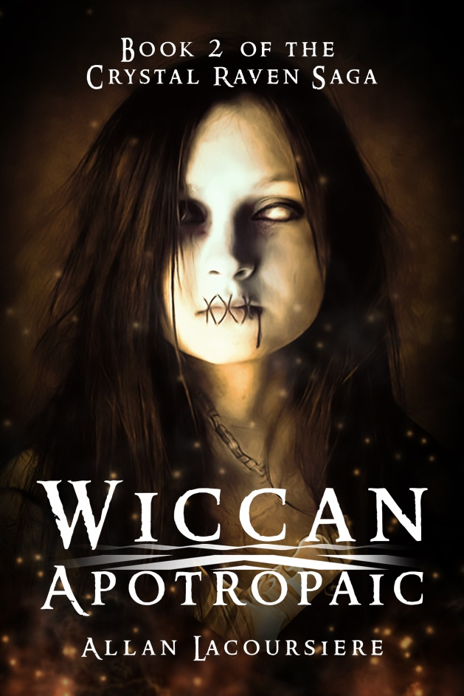

To end the war Crystal and the Ghost Sisterhood must find a lost Wiccan secret. And waiting for them is the last of her ancient enemies and the haunting tale of the Black Donnellys. Will they share the fate of this slaughtered family, or will they win through and find the Wiccan Apotropaic?

https://www.amazon.com/dp/1658762045
https://www.amazon.com/dp/B083QTSK3G

Ware the Milk Rabbit and Crossroads
This group of teenagers wrote the following two books in three months:

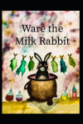

My first-year group of the Pens of John Paul II, they got the program off to an excellent start. Check out these two original stories:

Ware the Milk Rabbit:
This is the first novel written by students of John Paul II High School. The Pens of John Paul II is a novel-writing course where young writers participate in the writing of a novel. This year we had two groups, for a total of ten authors. Ware the Milk Rabbit: Born in a village whose citizens consider themselves the sole survivors of the Great Plagues, Kendra and her friends grow up believing only the offerings they leave for the Milk Rabbit keeps them safe. And then one night she sees a man-at-arms stealing the offering of her friends, and soon she and the others must journey into a world they no longer believe exists…

https://www.amazon.com/dp/1792752547

Crossroads:

The Pens of John Paul II is a novel-writing course where young writers participate in the writing of a novel. This year we had two groups, for a total of ten authors. Our Crossroads writers are Tyler Cadorna, Julia Gravelle, Patience Ineza, and Tara O'Shea. Maria and her family come to Canada looking for a new life. Soon Maria is involved with the same gang as she had been back home in El Salvador. When Maria meets new friends, however, she comes up on the wrong side of the gang. Soon she and her new friends are a target for their bullying and are looking for a way out. Can they turn the tables on the bullies, or will Maria be forced to transfer to a new school?

https://www.amazon.com/dp/1792979495

Promotions

Twenty-six authors have come together to share their work with you at a discount. Check these exciting novels out now!

https://storyoriginapp.com/to/hQYVTtC

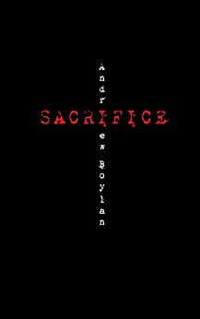

A filmmaker down on his luck.
A desert town full of secrets.
An ancient cult reborn.
After a decade of failure in Hollywood, Benny Hernandez has run out of money and options. No matter how bad the times have gotten he can’t imagine ever going home again.
The small, desert town where Benny grew-up holds nothing but nightmares that he still hasn’t entirely awoken from.
Late one night, his old, high school girlfriend, Diana Armijo, calls begging for help. She believes the cult they escaped years ago has resurfaced in the mountain village nearby.
Can Benny face the demons of his past to tell the story of a lifetime?
If you like stories about ancient mysteries and desert towns plagued by evil than you will love Andrew Boylan's tale of psychological terror.

https://storyoriginapp.com/swaps/2bc85dea-a34d-11ea-b905-ff96ff3efc09

During this difficult time, I wish you and your family well. Stay safe. Stay home and read a book!

And as always, visit me at:

http://www.allanlacoursiere.com

