Contents
01: Jean-Claude Beaucoeur
02: Darkhaven
03: Goth
04: Laurie Elizabeth Flynn
05: Promotions

Jean-Claude Beaucoeur

He is a slight man prone to wearing sweater vests and bowties, and who teaches kindergarten at a local Catholic school. He is studious, spending hours reading texts and books, many in obscure languages.
Jean-Claude has a surprisingly good basketball shot, and helps out at a youth centre in the Bronx. He is also a maniac behind the wheel who refuses to believe a car comes with a break, or that the sidewalk is not part of the roadway.
He also happens to be the head of the demon-fighting Brotherhood. Is there a monster in your basement? Then Jean-Claude Beaucoeur is the man you want to call.

Crystal Raven. Available at:
https://www.amazon.com/dp/1708716734
And on Kindle at:
https://www.amazon.com/dp/B081KRCZTV

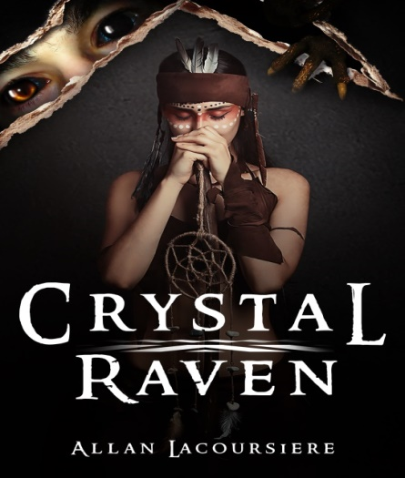

Dark Haven
  - Book 1 of the Dark Haven Series
The world is safe and their adventures are finished. Or is it? Aiko, Alex, Ember and Jean-Claude wake up to a world three-hundred-and-thirty-two years into Armageddon, and their failure may have been the cause of it all. With the Finder’s Stone, a powerful Wiccan crystal, they must cross a world filled with demons and other hideous creatures to find the answer.

Coming in 2020

Upcoming Series
  - Like what you read. Coming soon:
Goth:
Fifteen and the only Goth in a small town can be a tough combination. When you might also be a witch, it is impossible. Join Zero as she explores haunted sites while searching for her missing father in this funny series.

Coming in 2020

Laurie Elizabeth Flynn
Laurie Elizabeth Flynn is a local YA author who joined us this year in Pens of John Paul II. This is a novel writing program I run at a local high school here in London. My writers are between the ages of 14 and 17, and each year we write and publish a complete novel.
Laurie has three books published and all are worth reading:
Firsts
Last Girl Lied To
All Eyes On Her

Check them out, and check out our interview and writing session with Laurie on our YouTube channel.
Pens of John Paul II

Promotions
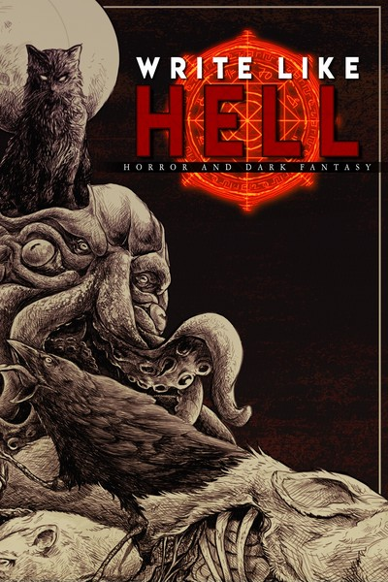

Write Like Hell is the first horror and dark fantasy anthology released by indie publishing house Sentinel Creatives. Adapted from the zine released under the same name, "Write Like Hell" features stories from Scott Miller, Justin Probyn, and Mitchell Luthi. Between these pages you'll find a feast of fiction for you to sink your teeth into. This release sees the debut of not one but two writers: Scott Miller's "Panopticon" is as unsettling as it is well-crafted. Pessimistic horror at its finest, this is a must-read for fans of Connolly and Ligotti. Justin Probyn's debut, "Void Born," blends gritty sci-fi, gore, and cosmic horror into one seamless festival of the obscene. And Mitchell Luthi's "Dregmere" and "Lord Ruthven" are modern and titillating takes on the Victorian Gothic genre.

https://storyoriginapp.com/swaps/8caca4e2-3c21-11ea-b815-6b9cbfd5ad80

And as always, visit me at:

http://www.allanlacoursiere.com

